**CLOUD FRONT & ROUTE 53**

**Summary-** Route 53 can point your domain to a CloudFront distribution for fast, secure content delivery, Ensures **global reach, low latency, and high availability** for web applications.

* Configure VPC peering in cross regions  
   Create VPC in north virigina and ohio  
  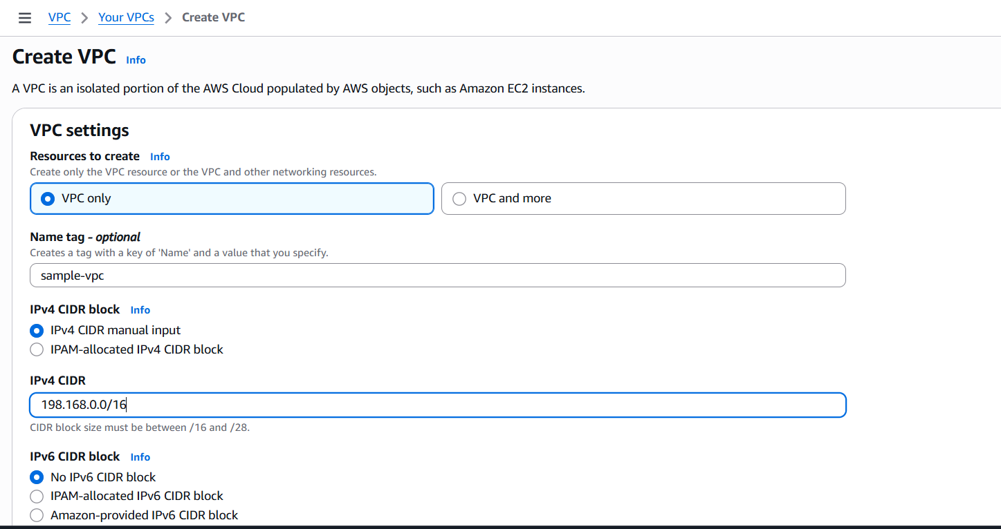

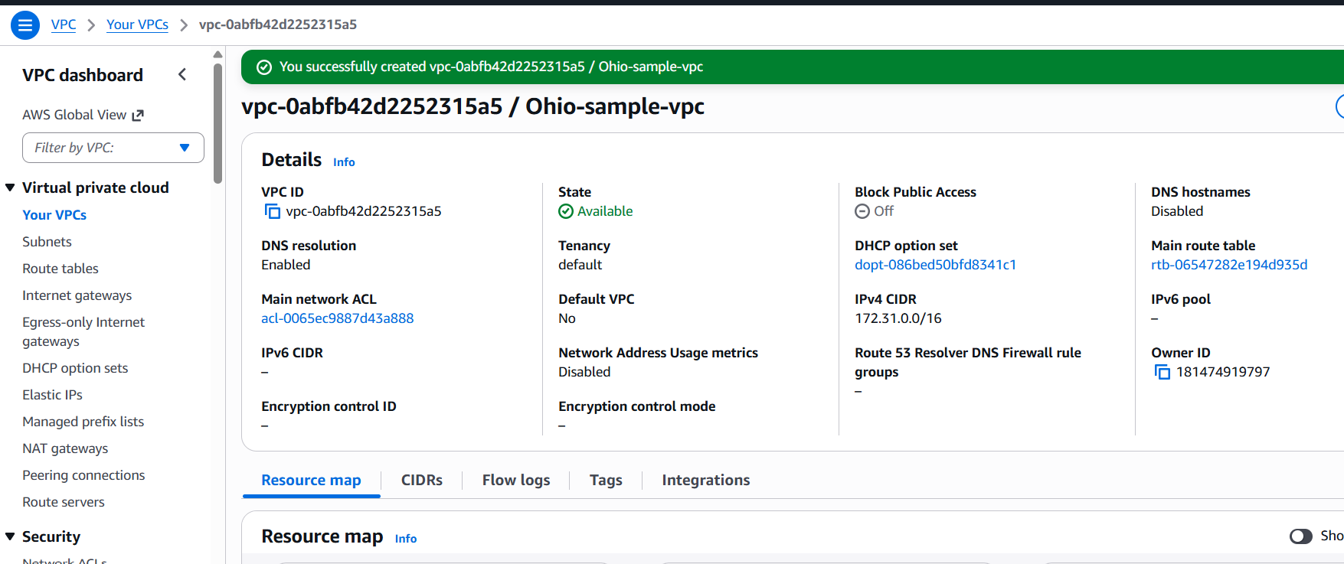  
Now go to virgina task and click on peering connections  
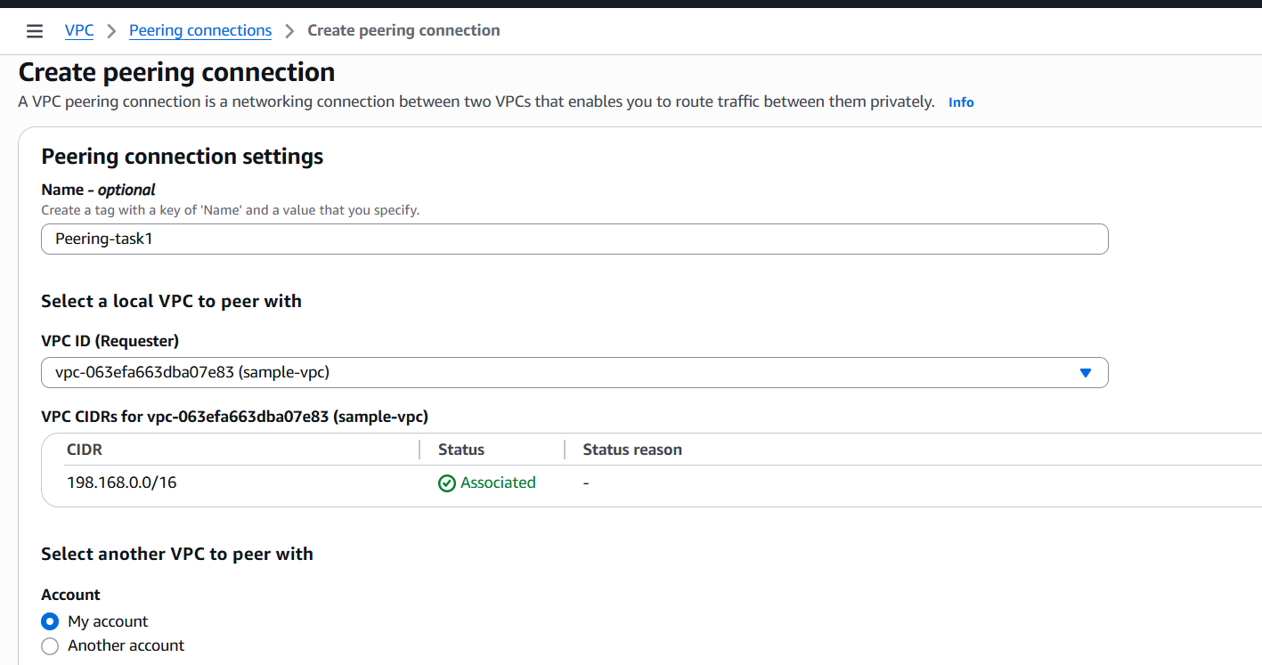

And provide the VPC id of ohio region and click on create  
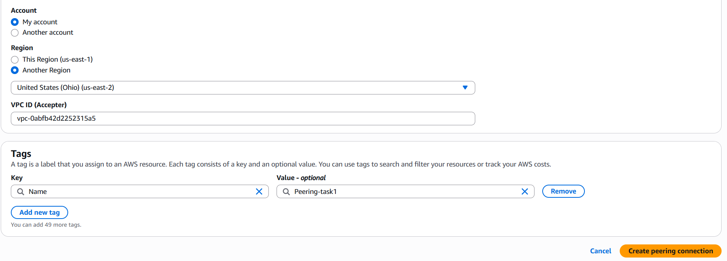  
Then peering request will be assign from virgina and go to ohio region and accept the request  
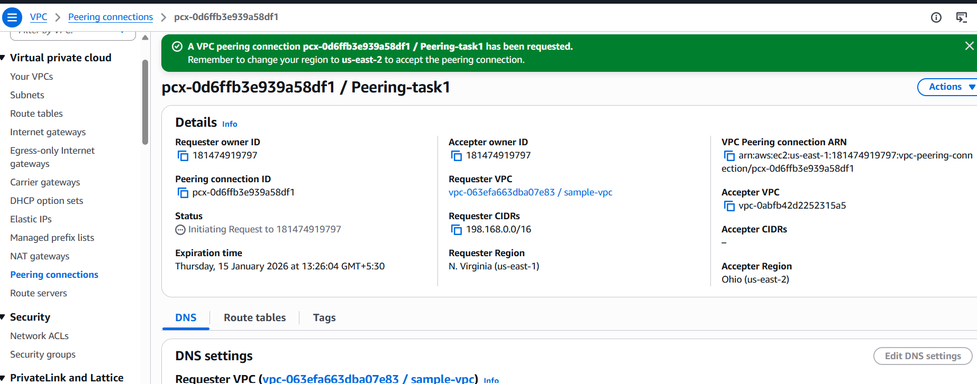  
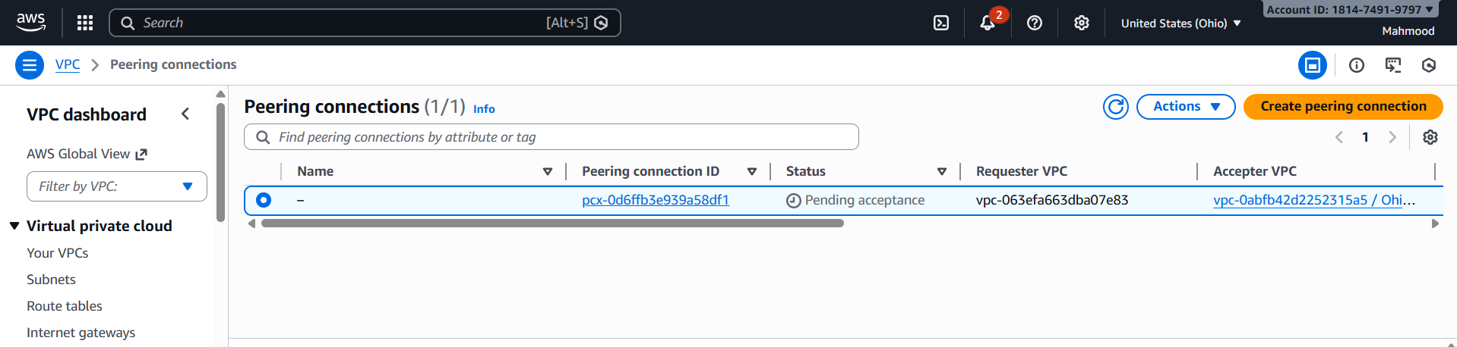  
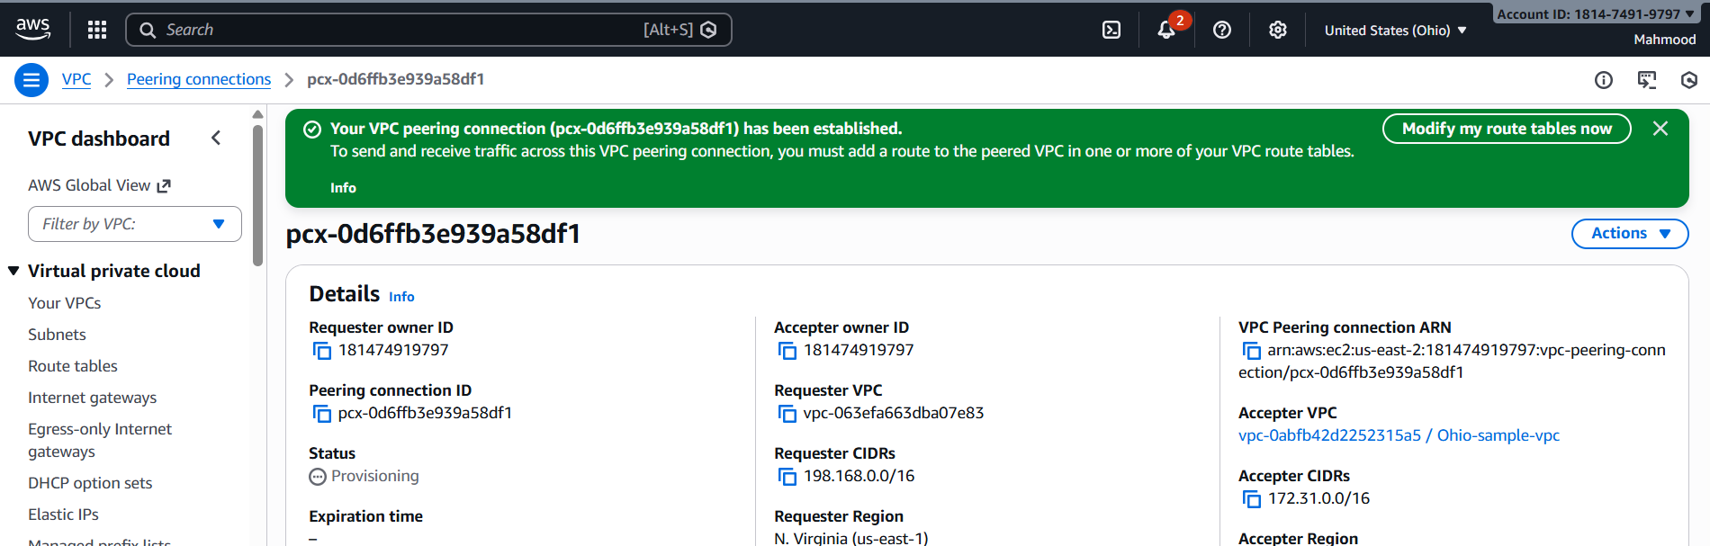  
Add a route: Destination – the other VPC’s CIDR (e.g., 192.168.0.0/16)

Target- the VPC peering connection ID

Do this in both VPCs.  
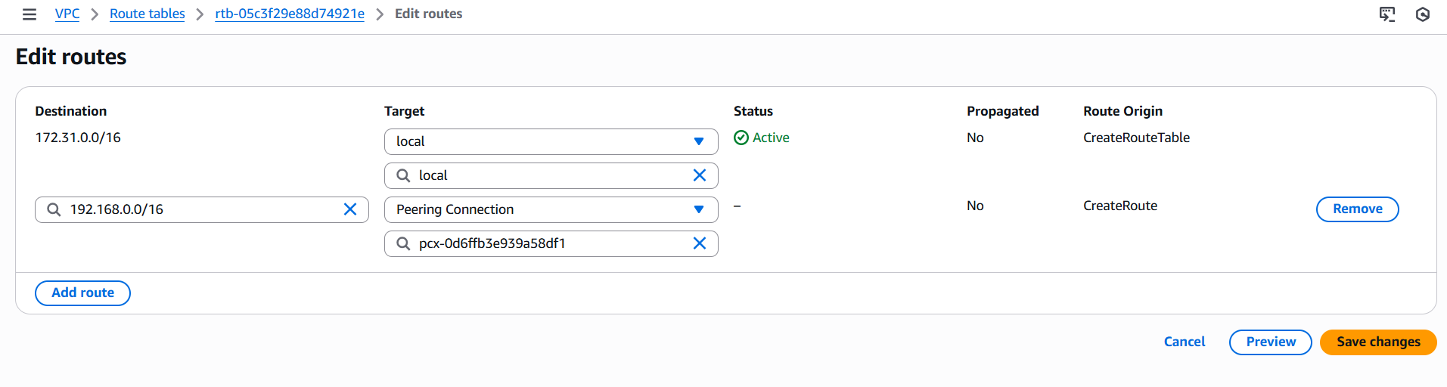  
Launch EC2 instances in each VPN  
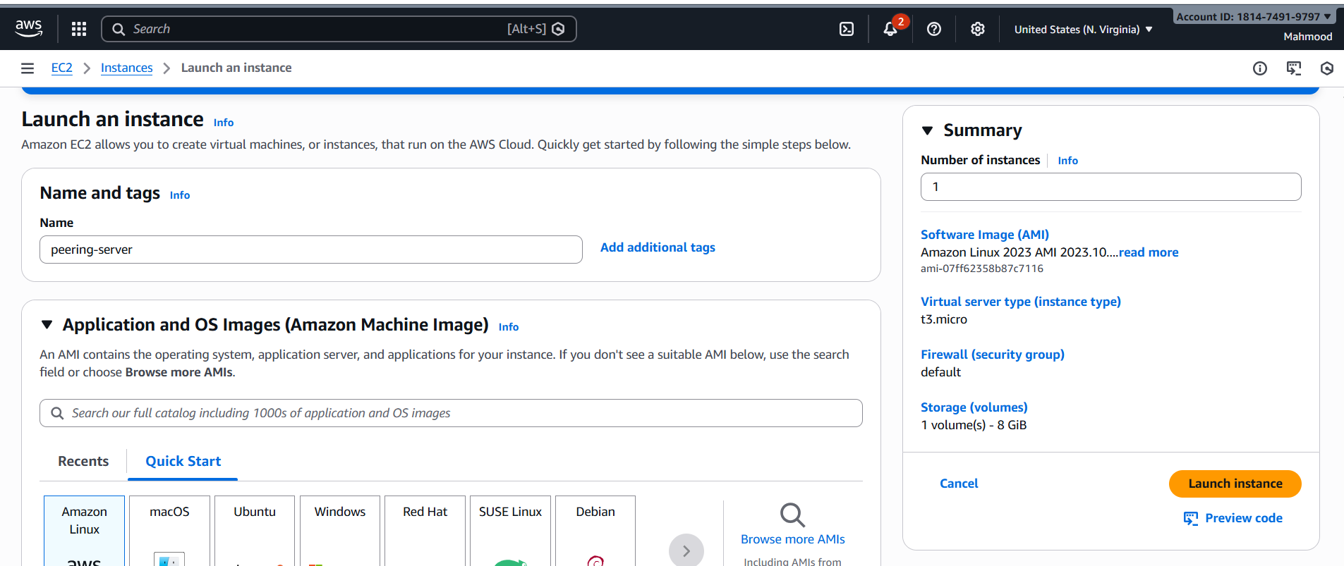  
And connect ssh with public ip   
  
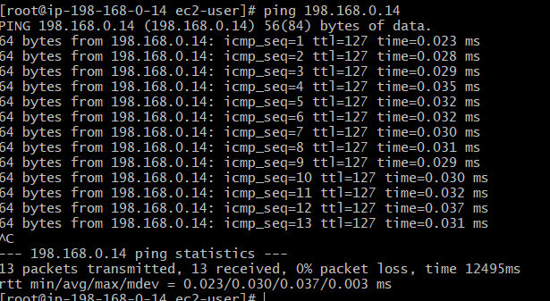

* Purchase one domain from GoDaddy

Go to GoDaddy website and sign in   
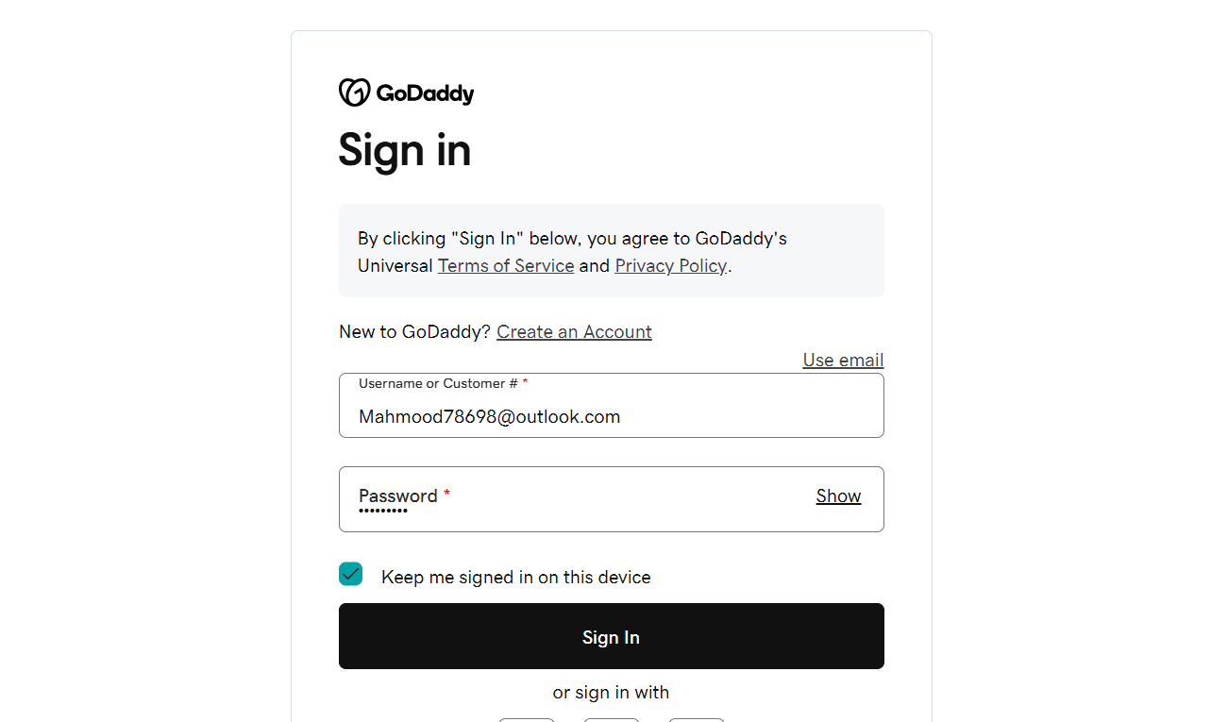  
And click on website and give the website name as mahmood0786.info and add it cart and make the payment   
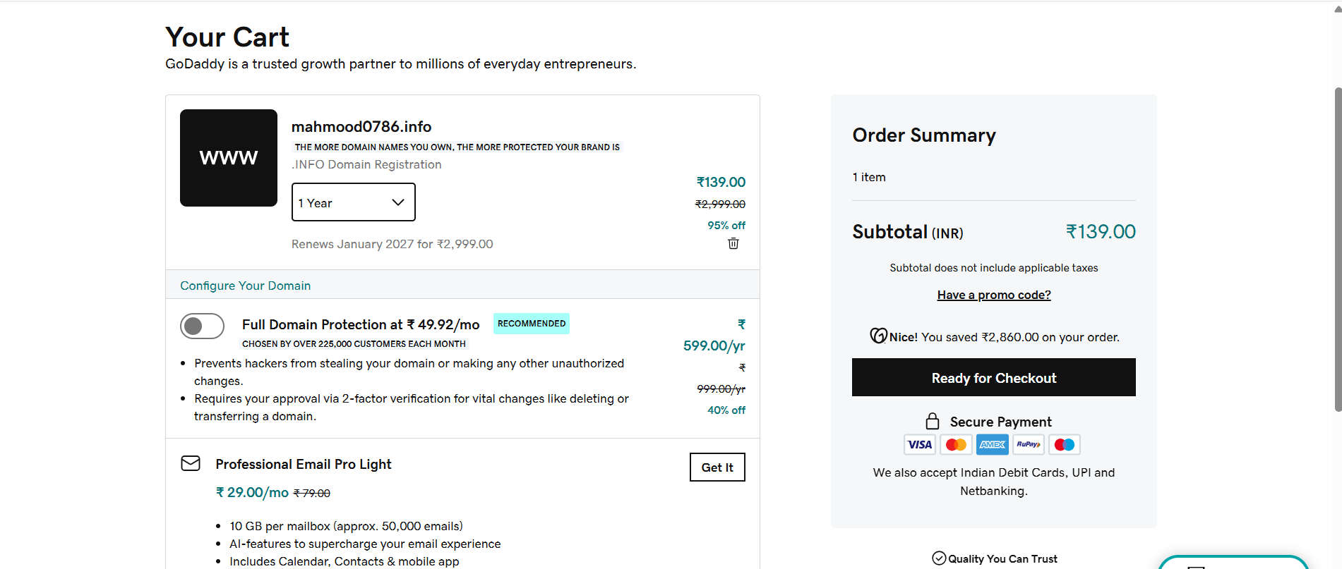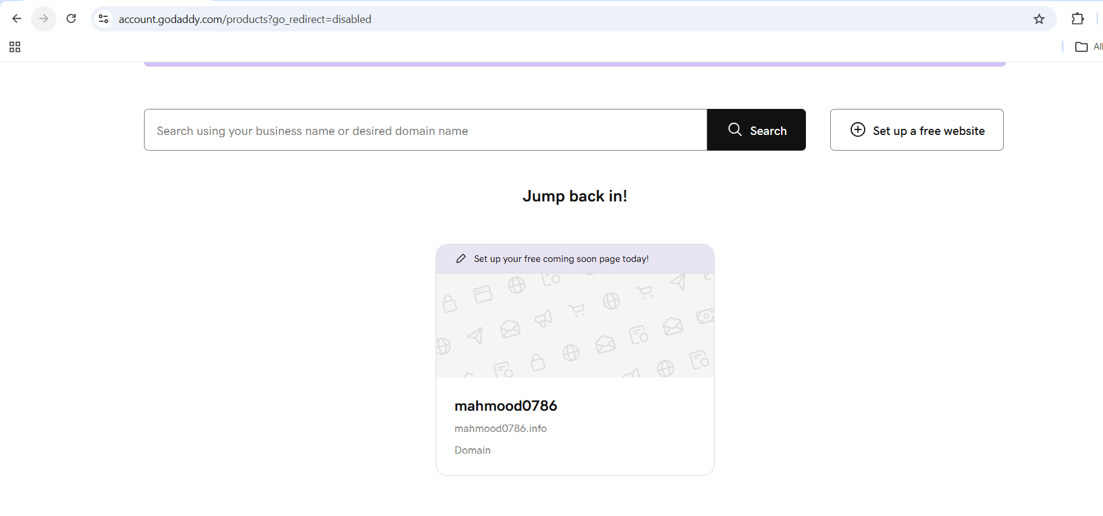  
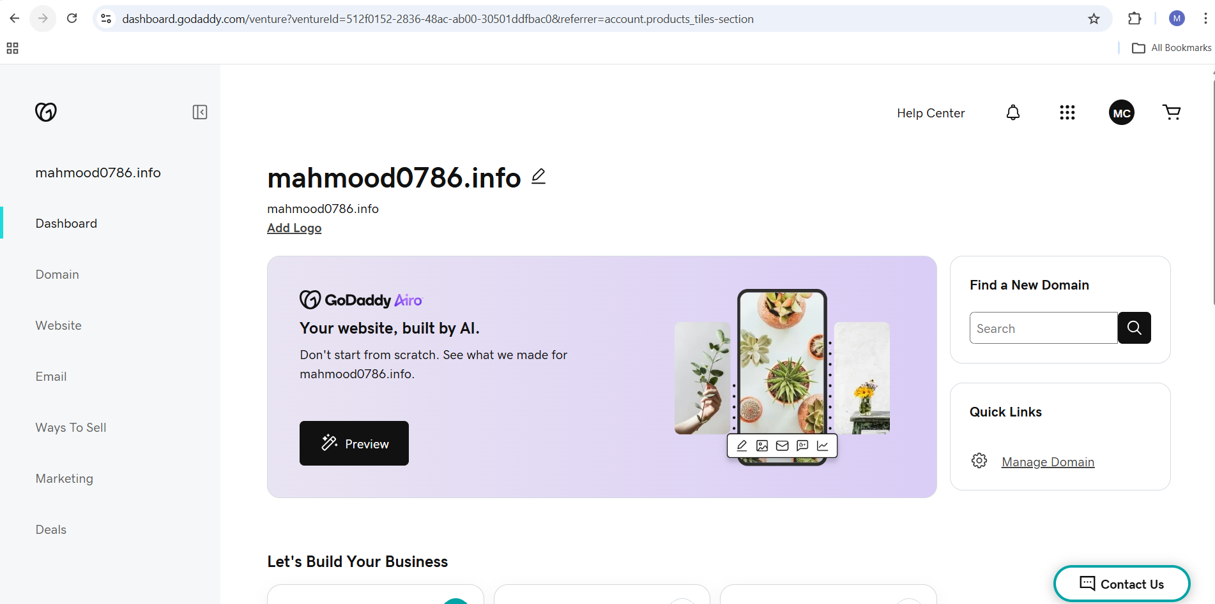

* Deploy static website in S3  
  Create a s3 bucket with unique name   
  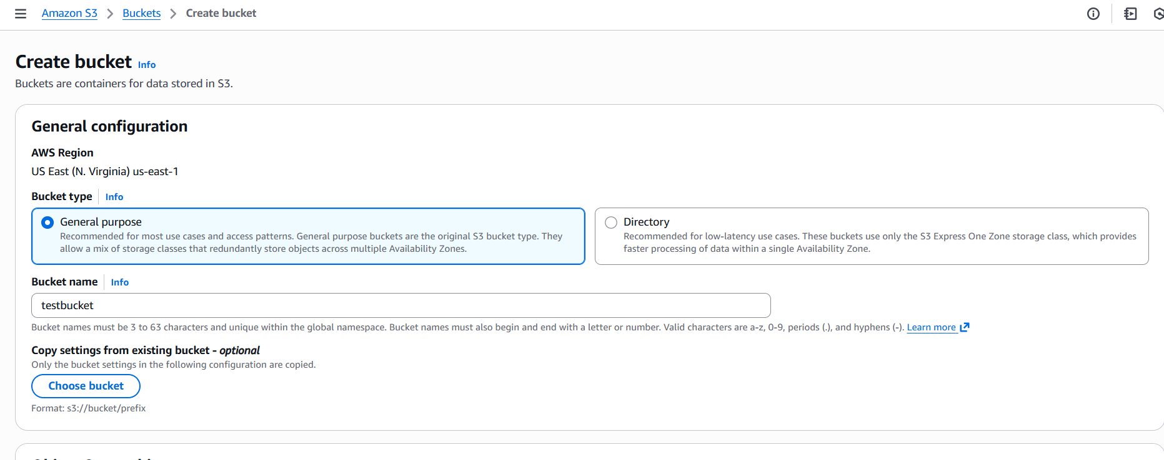  
  Enable static website hosting by visiting properties in our backet and enable  
  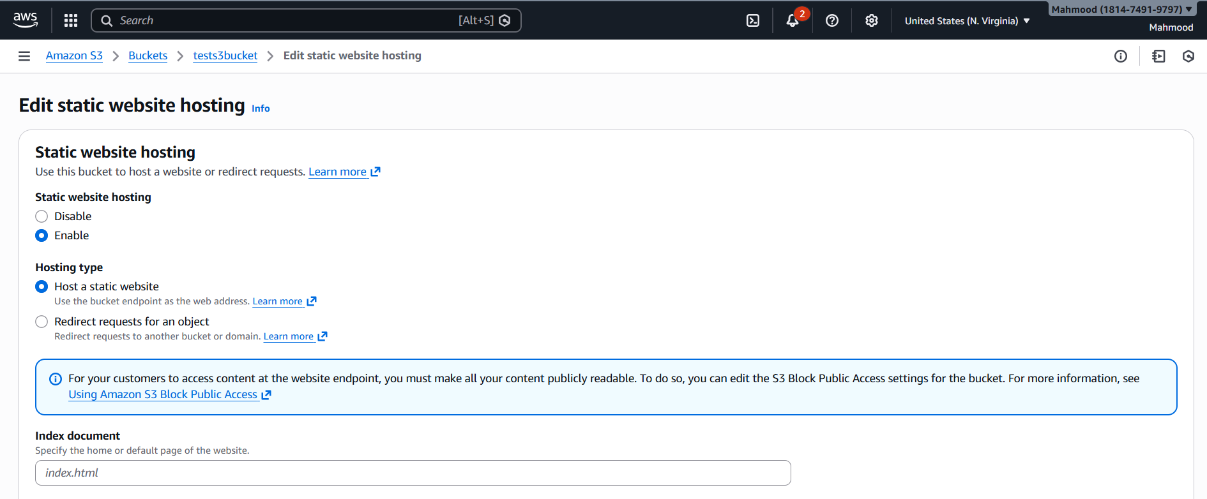  
  And provide the index.html and error.html and upload the files and make public using ACLS  
  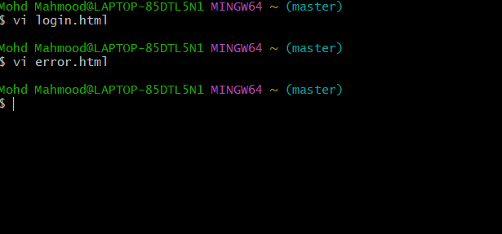  
  and copy the url from login.html and error.html and paste it on browser  
  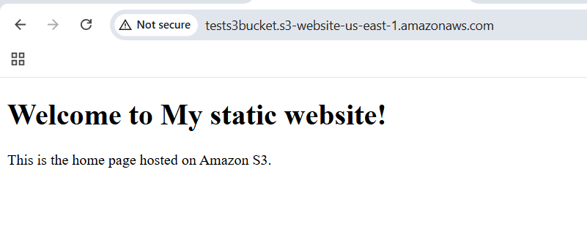  
  And delete the index html to check the error.html  
  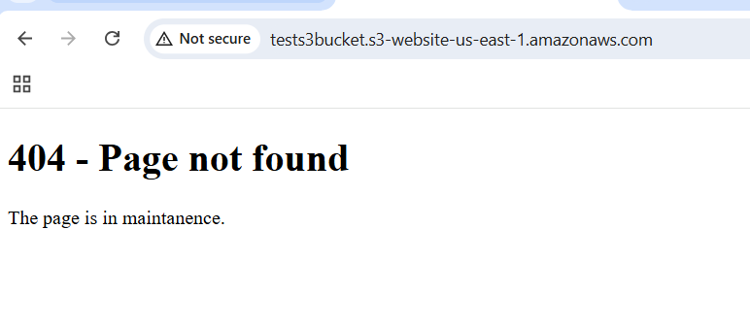
* Create a CDN and attach one SSL certificate  
  Open cloud front and create distribution   
  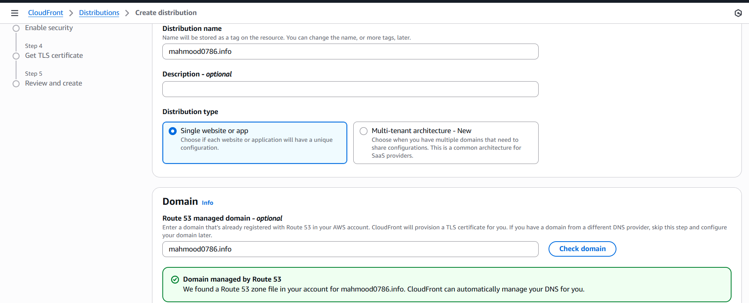  
  And provide origin as bucket URL then click on Next  
  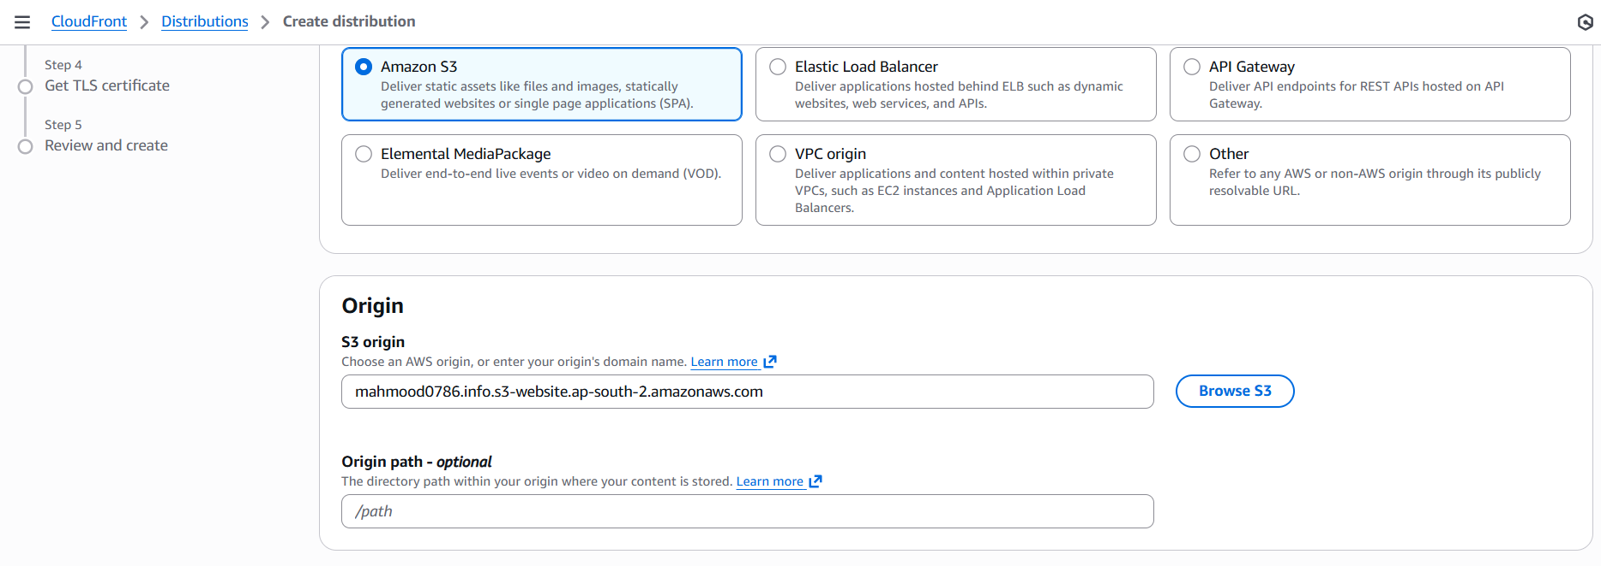  
  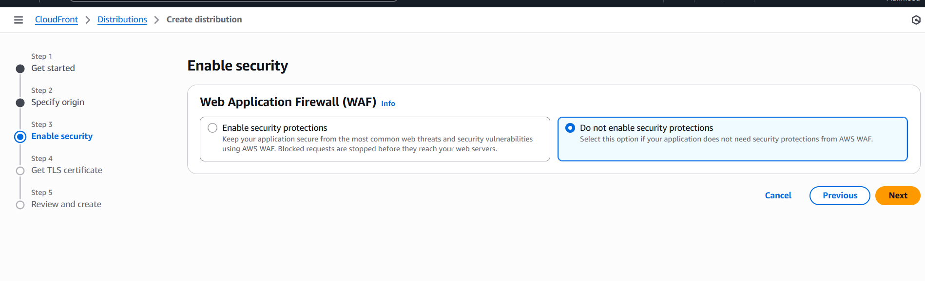  
  And you will see option as TLS certificate and click on create certificate in ACM  
  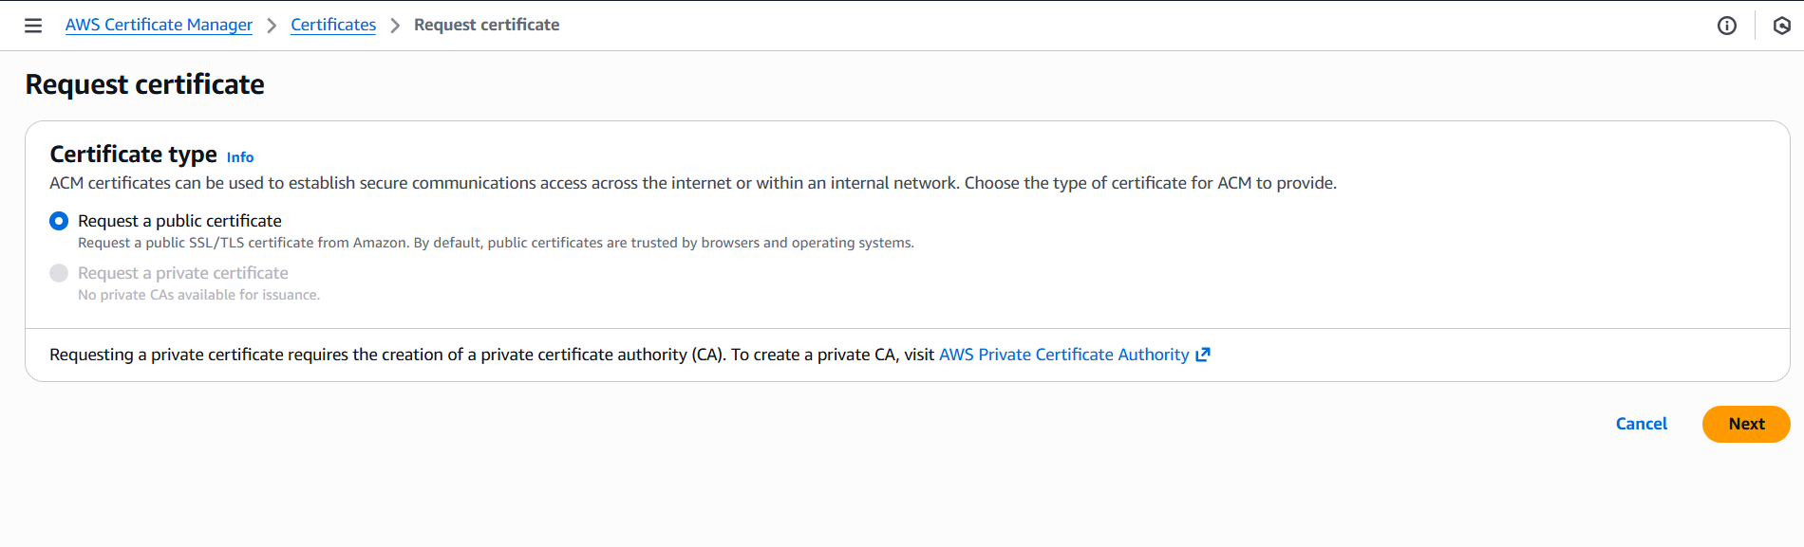  
  And click on request a public certificate then click on Next  
  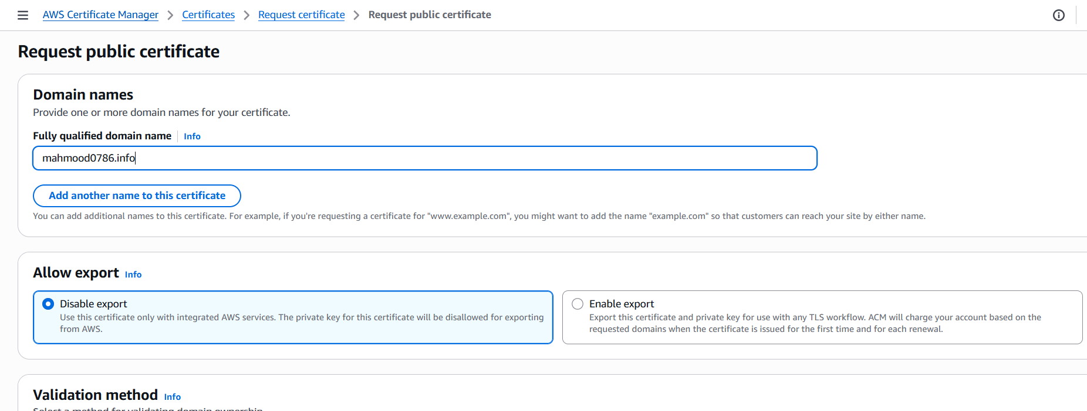  
  Add same domain and click on request and it is in pending validation and we need to create DNS records in Amazon Route S3  
  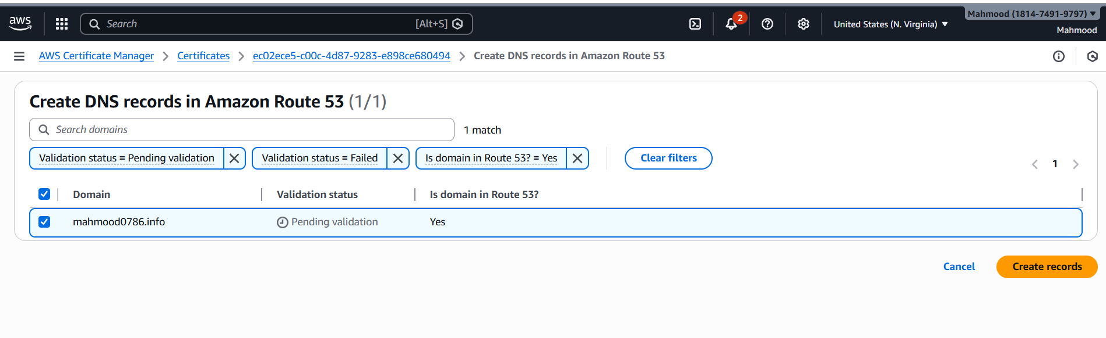  
  And then status success  
  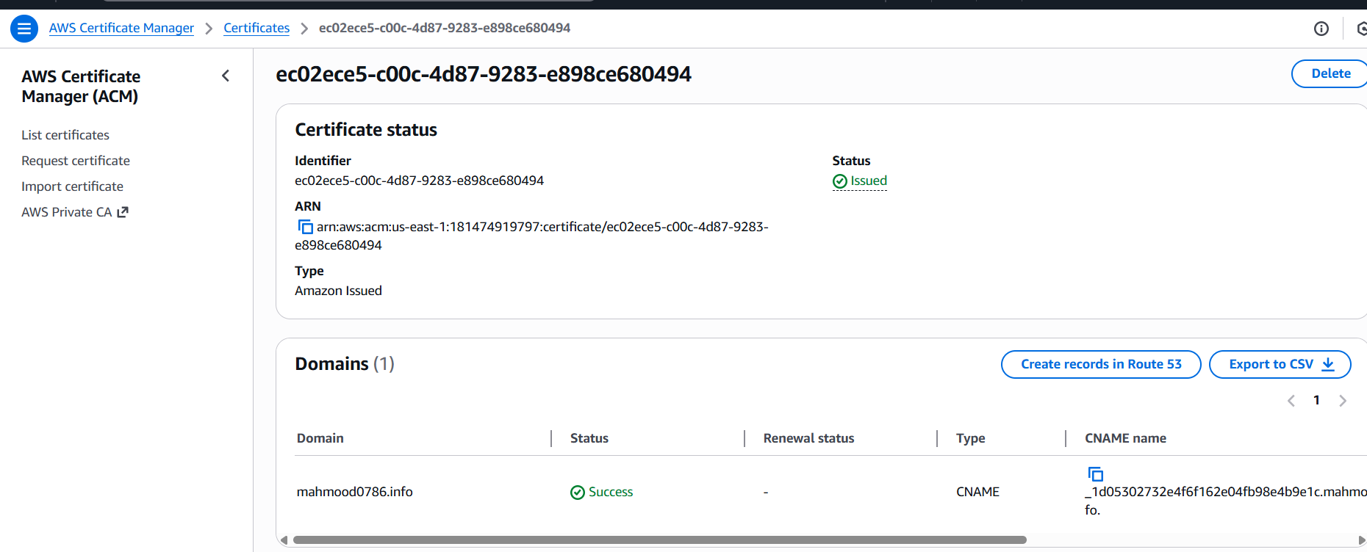  
  In TLS certificate our certificate gets visible and click on next  
  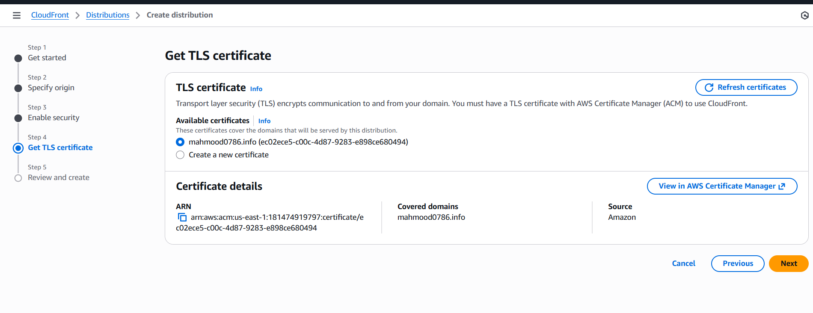  
  And click on create Distribution   
  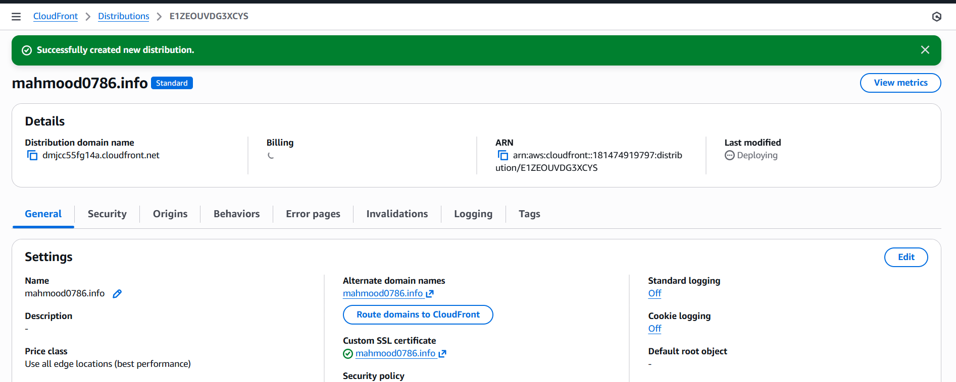  
  And copy the distribution domain name and paste it on browser  
  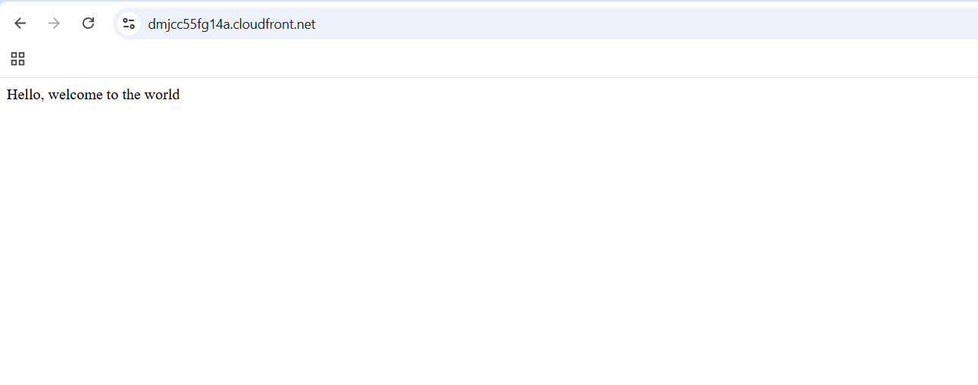
* Create a Route 53 hosted zone and map the domain with the CDN  
  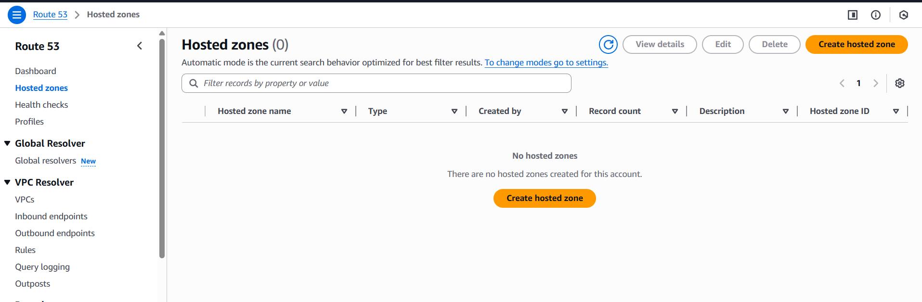  
  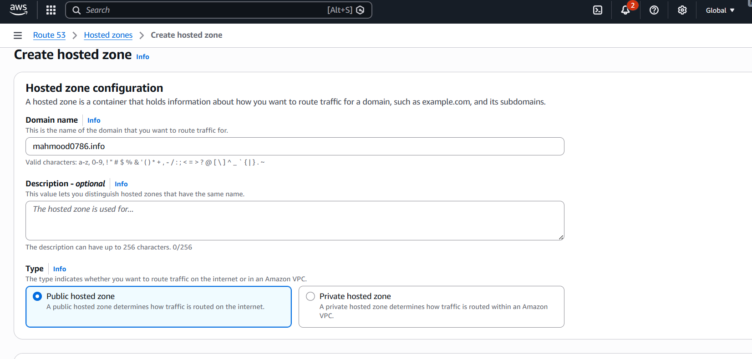  
  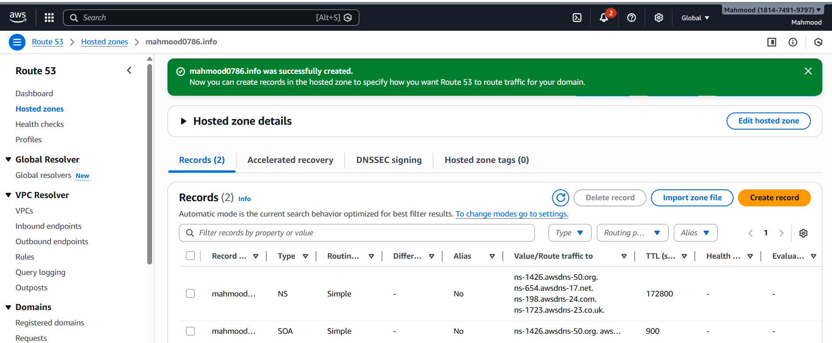  
  ns-1426.awsdns-50.org  
  ns-654.awsdns-17.net  
  ns-198.awsdns-24.com  
  ns-1723.awsdns-23.co.uk  
  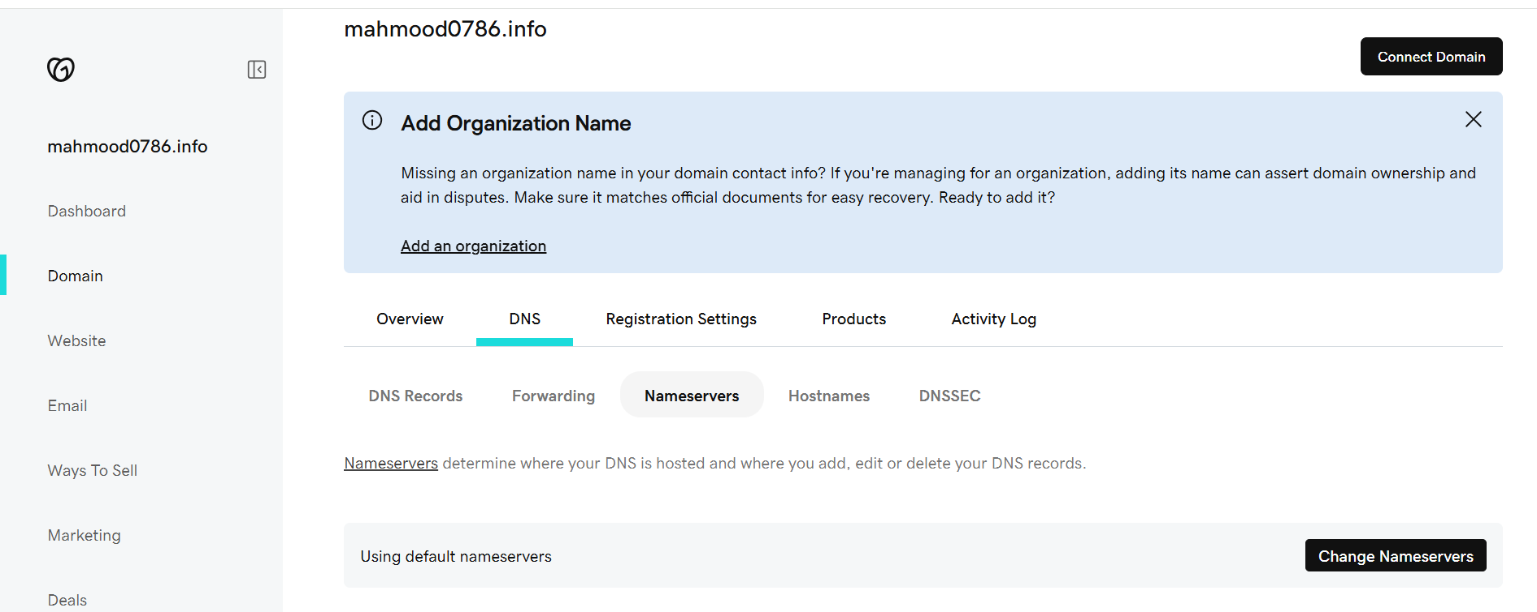  
  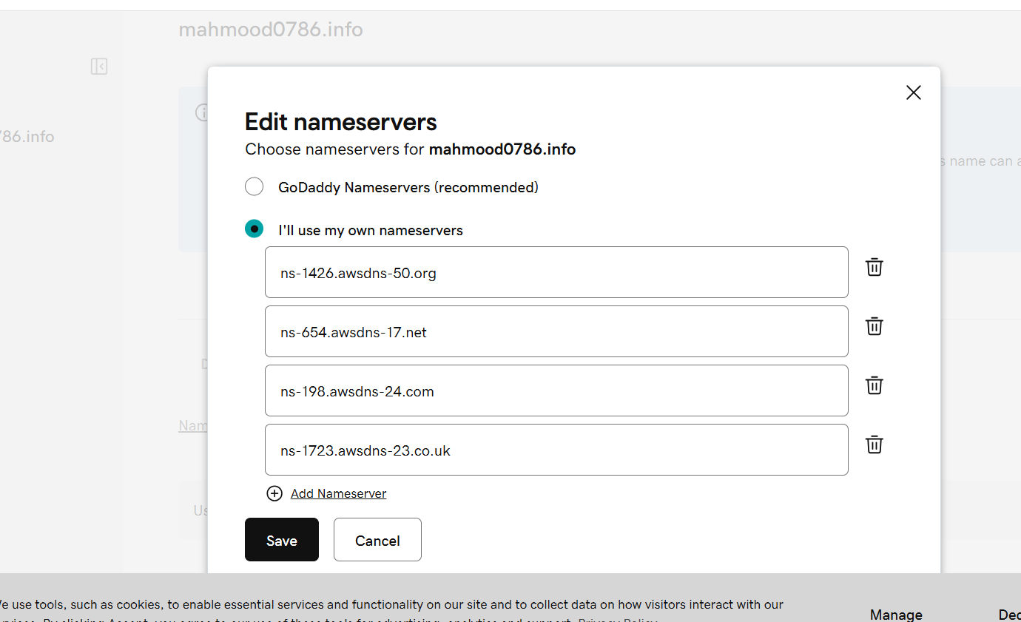  
  Domain added successfully and go to s3 and create record and enable alias and select cloud front distribution and save the record  
  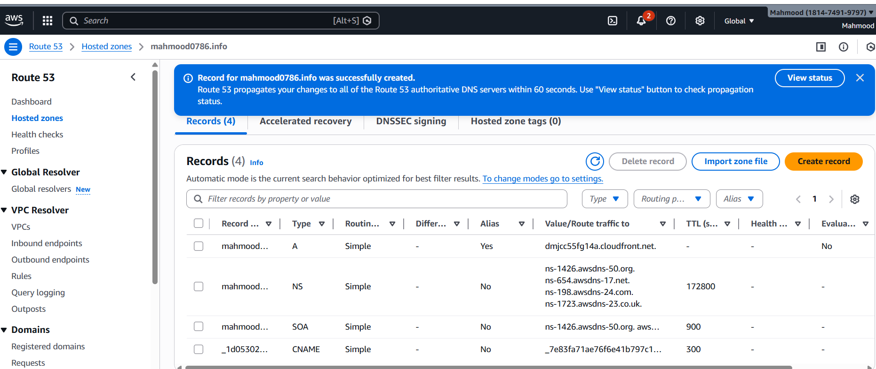  
  copy the distribution domain name and paste it on browser   
  

* Update the index.html in the S3 bucket and ensure the updated file is accessible using the domain name  
   Create one s3 bucket in the name of domain name and enable the static website hosting and add the index.html and copy the bucket url and check it on website  
  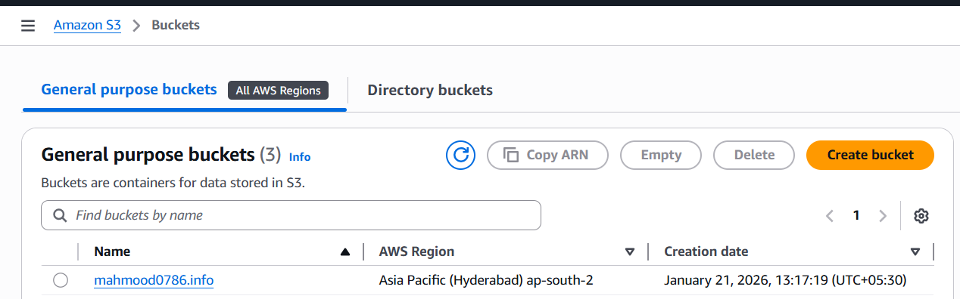  
  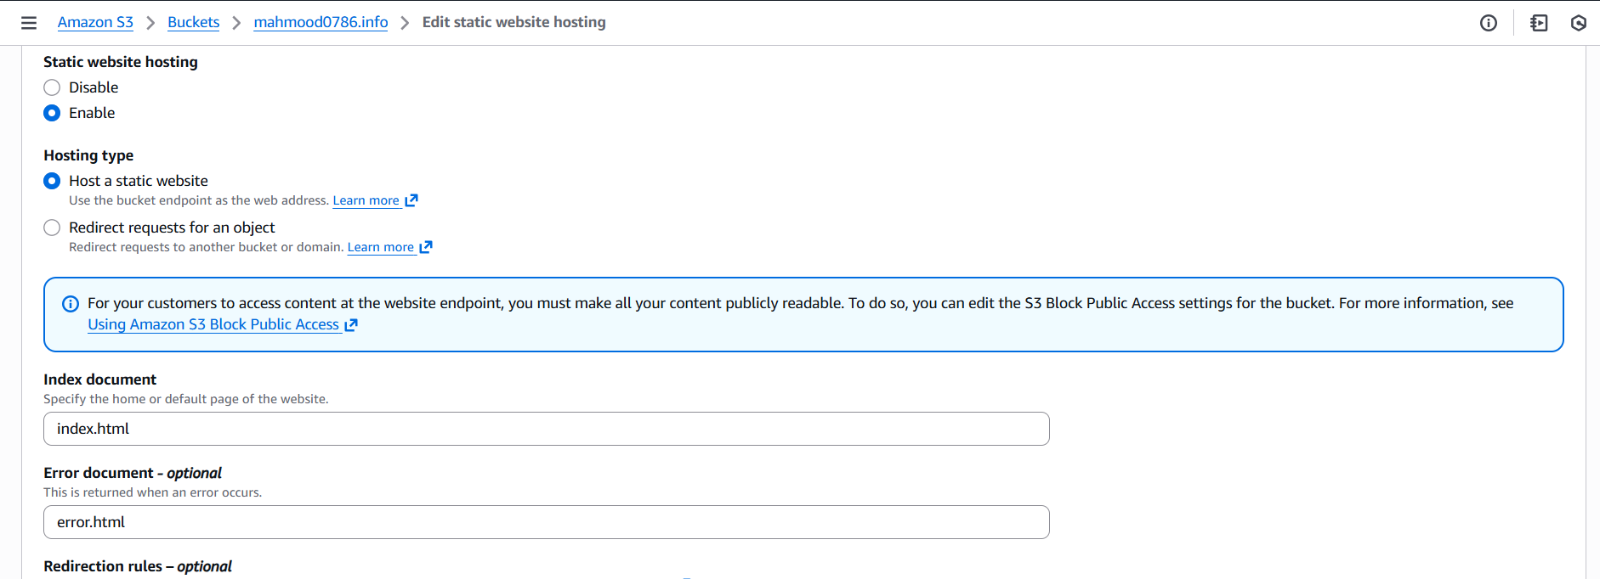  
  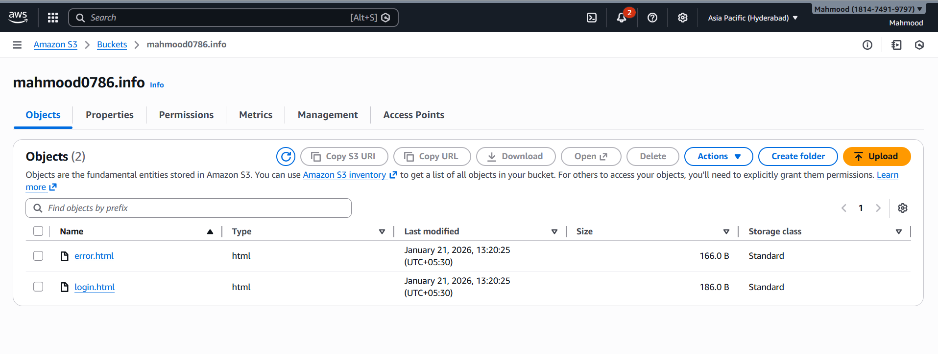  
  And make as public using ACL  
  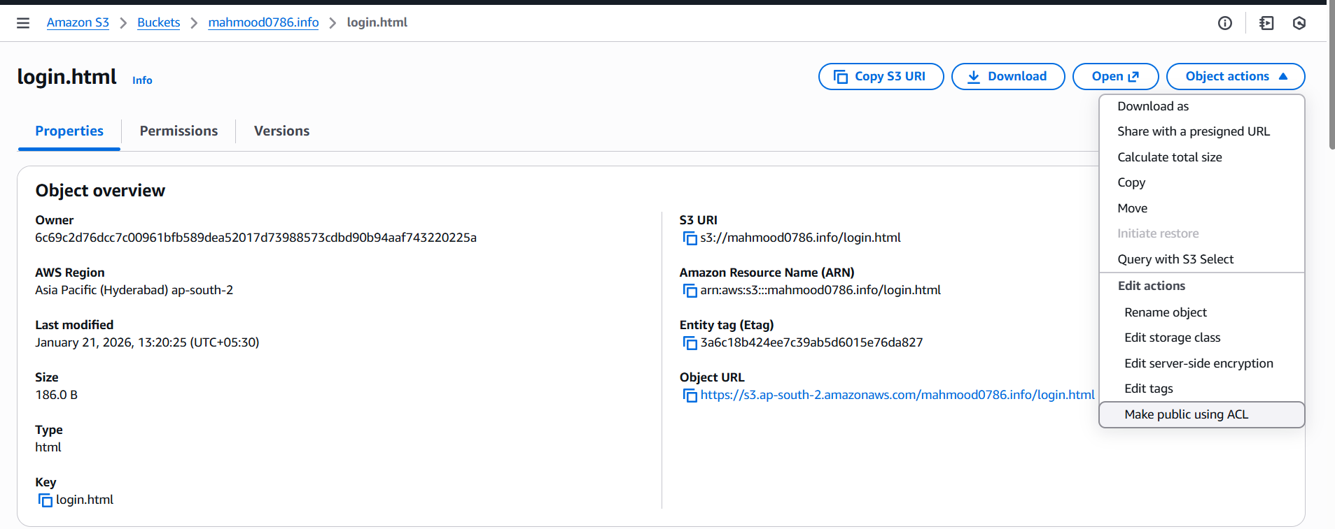  
  And then copy the bucket url from properties and paste in n browser   
  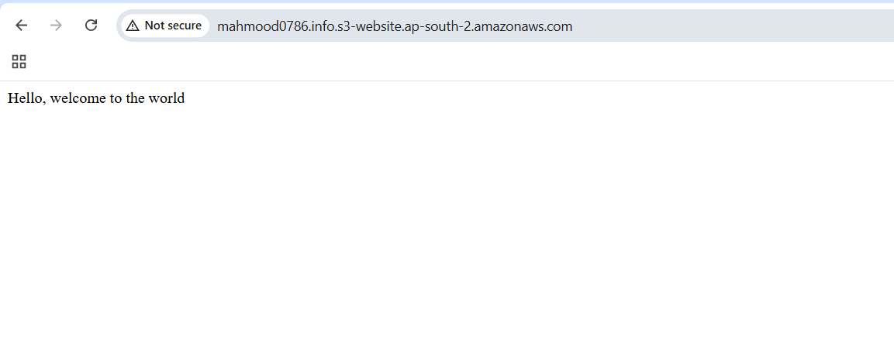
* Share the domain name in Slack to test the connectivity

Mahmood0786.info

**Issue Faced-** issue faced after creating ssl certificate and adding the alternate domain names to execute the output

**Conclusion –** Successfully completed the assign tasks and configure the VPC peering in cross regions and purchased the domain.info from GoDaddy and deploy static website in s3 and created the cloud front and attached the SSL certificate and hosted Route 53 to it and updated the bucket with domain name